**AML Assignment – 2**

**Rana Tej**

Analyzing the Relationship Between Training Sample Size and Neural Network Selection for Image Categorization.   
  
This paper describes how to create a convolutional neural network (CNN), which is a type of specialized software. This program's goal is to identify whether a picture shows a dog or a cat. The photographs from Kaggle are utilized to train the algorithms. Only a portion of the 2000 photos were used to train the software, even though there are thousands of shots available.

**Q1: Consider the Cats & Dogs example. Start initially with a training sample of 1000, a validation sample of 500, and a test sample of 500 (like in the text). Use any technique to reduce overfitting and improve performance in developing a network you train from scratch. What performance did you achieve?**

A. After being trained on a sample of 500 further photographs, the computer model was trained on a dataset including 1000 images. 500 more images were subsequently utilized to fully verify the model's effectiveness. A novel technique called dropout was used to reduce the program's reliance on the training dataset to prevent overfitting. Preprocessing involved resizing the photos, checking color quality, and changing the image files to a format that could be read by a computer. The software's accuracy rate during training was about 71.40 percent, but in testing, it showed an accuracy rate of about 99.42 percent.

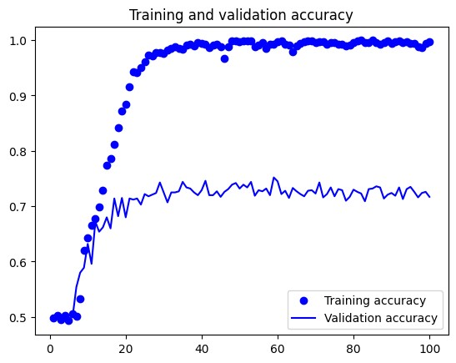

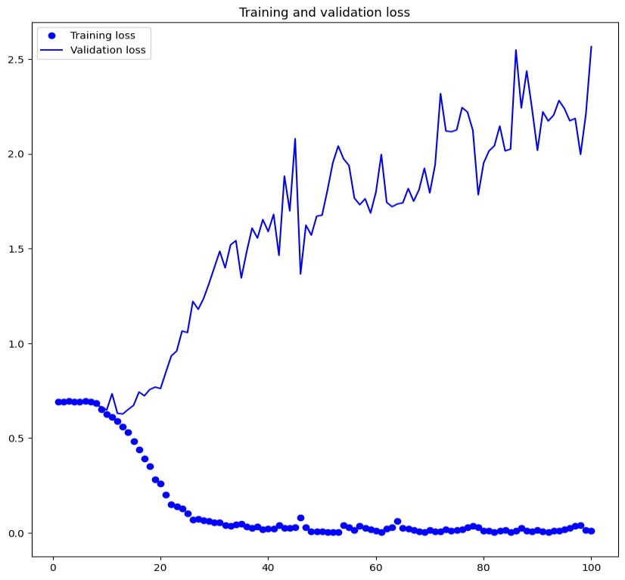

**Q2: Increase your training sample size. You may pick any amount. Keep the validation and test samples the same as above. Optimize your network (again training from scratch). What performance did you achieve?**

A. The computer model was trained using a larger dataset consisting of 1500 pictures. Additionally, 500 extra photos were used for testing, and a subset of those 500 photos was used for validation throughout the training phase. By applying augmentation methods such as rotation, zooming, and flipping of images, the algorithm was able to learn much better. As a result, the program worked better when these strategies were used. It displayed 86.05% accuracy during the validation phase and 80.30% accuracy during the training phase.

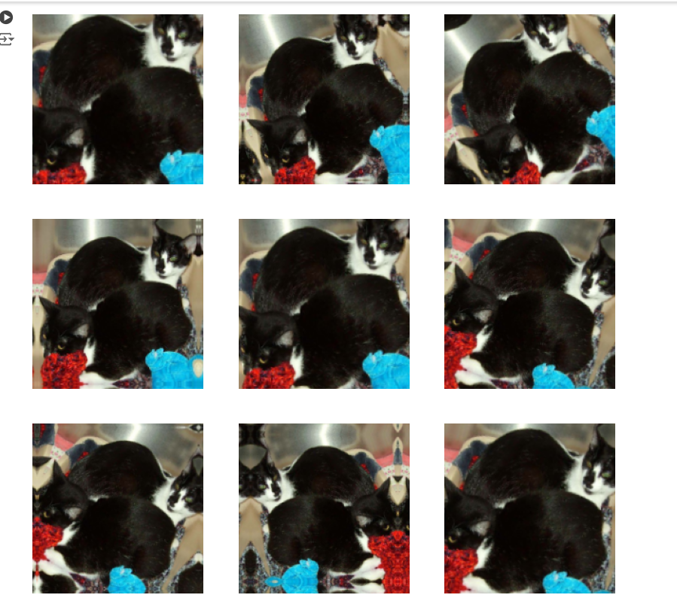

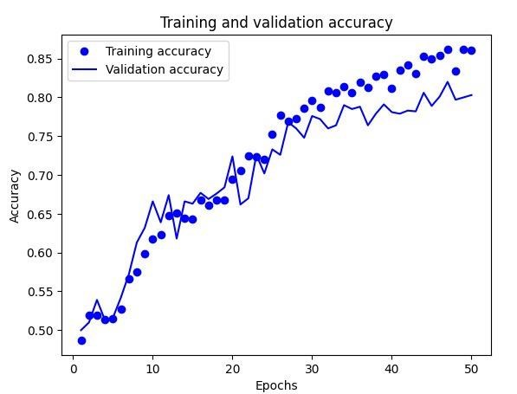

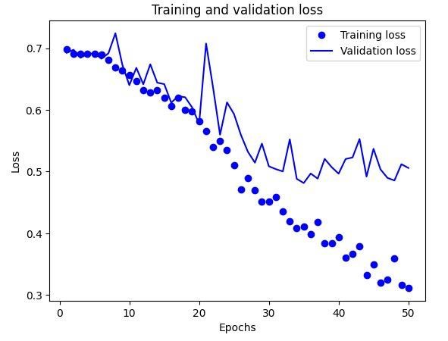

**Q3: Now change your training sample so that you achieve better performance than those from Steps 1 and 2. This sample size may be larger, or smaller than the previous steps. The objective is to find the ideal training sample size to get the best prediction results.**

A. An increased dataset of 2000 photos were used to improve the efficacy of the computer model. During the training process, these photos were often improved by flipping, rotating, and zooming. The program's ability to comprehend images was significantly enhanced using augmentation techniques with this larger dataset. Consequently, the accuracy rate of the program was roughly 77.90% in the validation phase and 86.84% in the training phase.

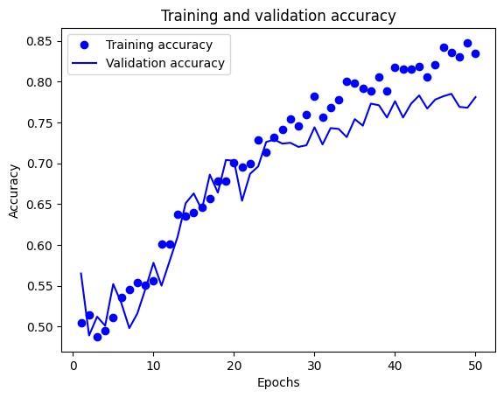

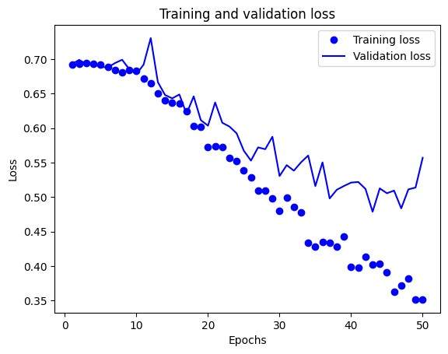

**Q4: Repeat Steps 1-3, but now using a pre-trained network. The sample sizes you use in Steps 2 and 3 for the pre-trained network may be the same or different from those using the network where you trained from scratch.**

**Again, use all optimization techniques to get the best performance**.

A. **Prior Training Without Augmentation:**

Using a pre-trained model—that is, a model that has been trained on a sizable number of photos—instead of augmentation techniques allowed us to conduct our experiment. However, we didn't use any augmentation methods, such rotation or flipping, on the photographs in this case. The pre-trained model performed remarkably well at photo identification even in the lack of these methods. It demonstrated an impressive 98.95% accuracy rate, or almost 100%, throughout the training phase, which is promising. This great accuracy, though, can also mean that the model is not adaptable enough to deal with new inputs and is overly reliant on the training dataset. The model's accuracy during validation was roughly 97.60%, suggesting that there might be difficulties in improving its performance beyond the training dataset

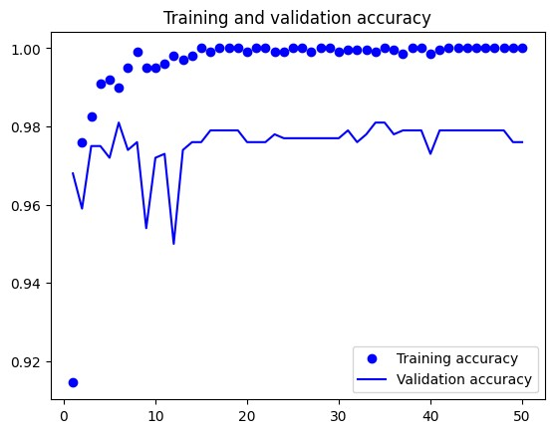

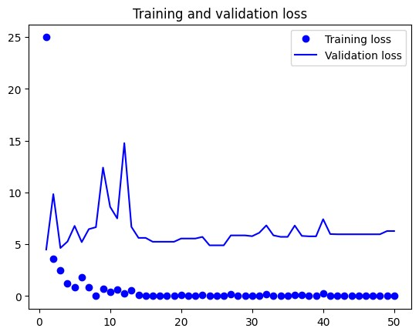

**Pre-Trained with Augmentation:**

With a validation accuracy of 97.40%, the pre-trained model demonstrated exceptional performance and did not require any extra tweaks to augment the dataset. After that, the author experimented with a fine-tuning strategy, which involves gently altering the pre-trained model to make it more appropriate for the task at hand. After more modifications and the application of data augmentation techniques, the model performed more skillfully. During training, there was about 99.15% accuracy, and during validation, there was 98.40% accuracy.

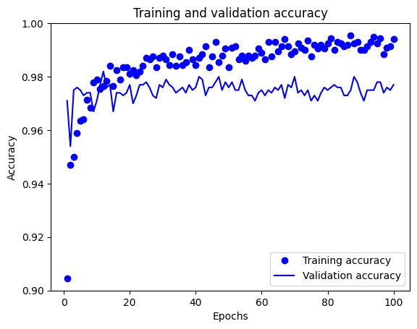

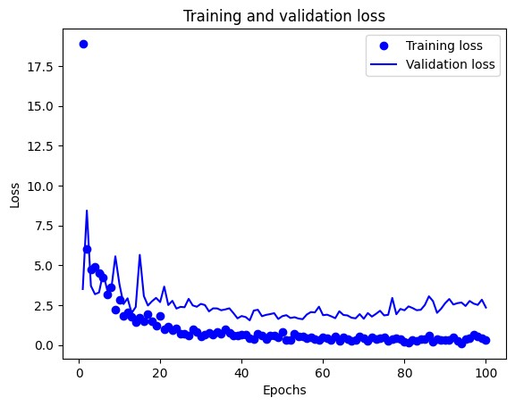

**Fine-Tuning with Augmentation:**

I experimented with the pre-trained model and altered the way further data augmentation was applied to further improve the model's performance. We call this technique fine-tuning. To optimize the pretrained model's fit for the specific task at hand, adjustments must be made to it throughout the fine-tuning process. Thanks to augmentation techniques like flipping and rotation, the layers of the previously trained model were able to adjust to the new, richer information. Significant improvement was made throughout the finetuning phase, enhancing the model's accuracy across the entire session. 99.80% accuracy was demonstrated by the model during training, while 97.50% accuracy was demonstrated during validation.

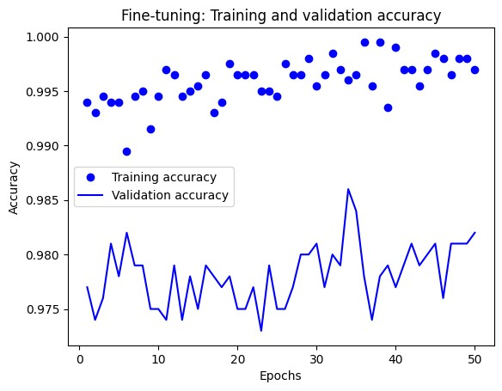

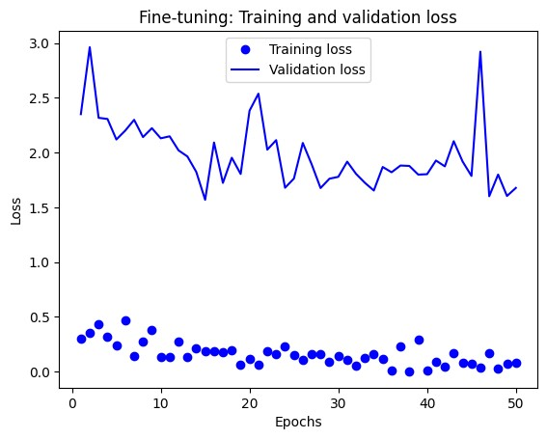

**Conclusion:**

In summary, the model's effectiveness is determined by the type and volume of data it uses. Improved recognition performance was shown in test results when the training dataset was expanded from 1000 to 2000 images, with accuracy increasing from 80% to 97.7%. Even higher results are obtained when pre-trained models are combined with methods for expanding the dataset. In conclusion, the author makes the case that enlarging the dataset and utilizing data augmentation methods can enhance the model's comprehension of the topic and allow it to provide more precise predictions.